Project Devlopment Delivery Of Sprint-2

|  |  |
| --- | --- |
| Date | 15 November 2022 |
| Team ID | PNT2022TMID15947 |
| Project Name | Industry-Specific Intelligent Fire Management System |
| Team Members | Balaji P (Team Leader)  Akilan A  Dinesh S  Arun R |

# MONITORING SENSOR VALUES

Display the temperature values in the dashboard:

Submitted by: Balaji P (Team Leader),

Akilan A,

Dinesh S,

Arun R

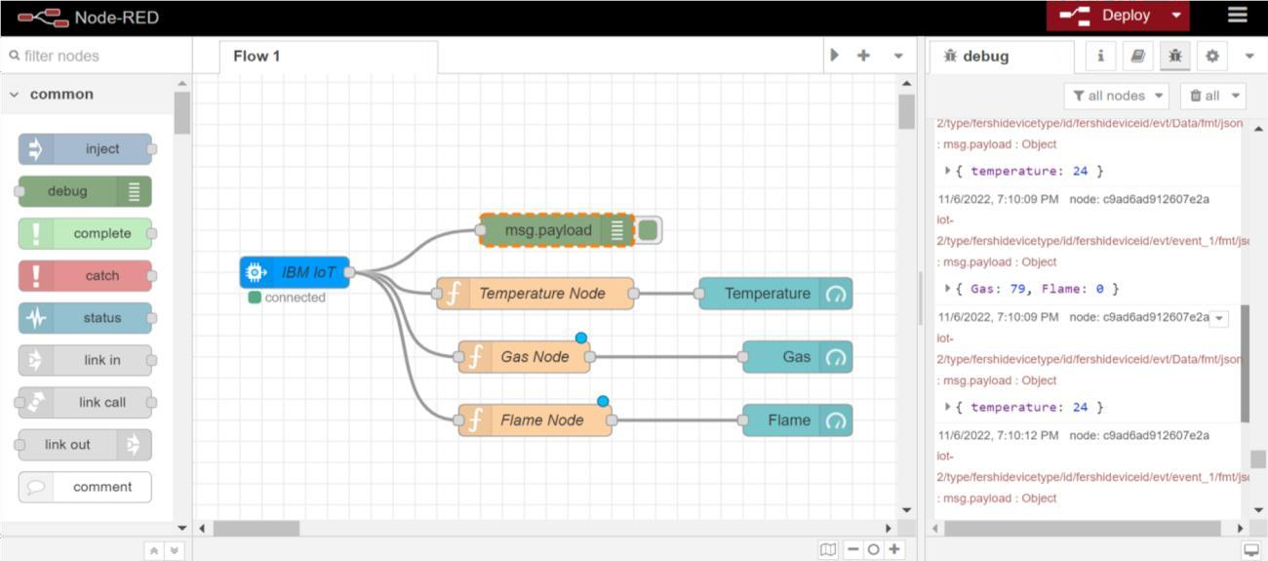

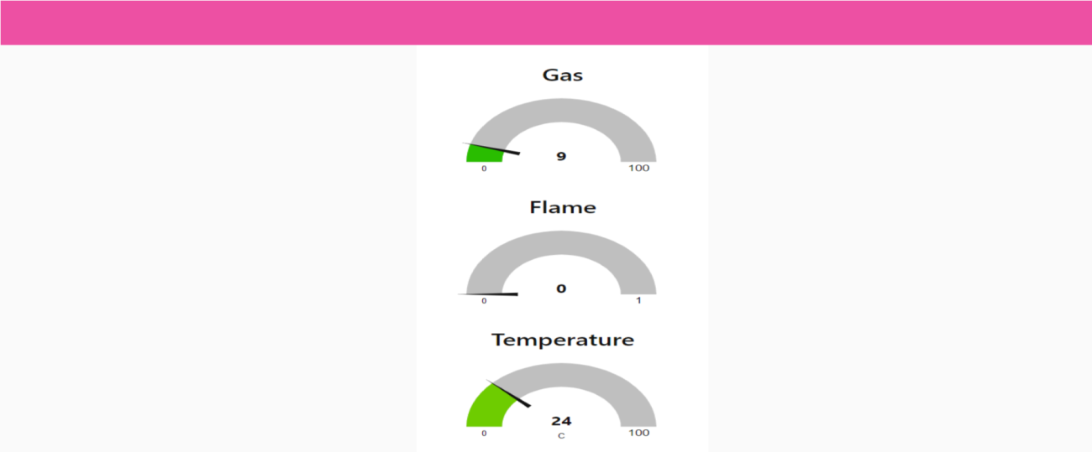

# Displaying flame sensor values:

**SUBMITTED BY:** Balaji P (Team Leader), Akilan A, Dinesh S, Arun R

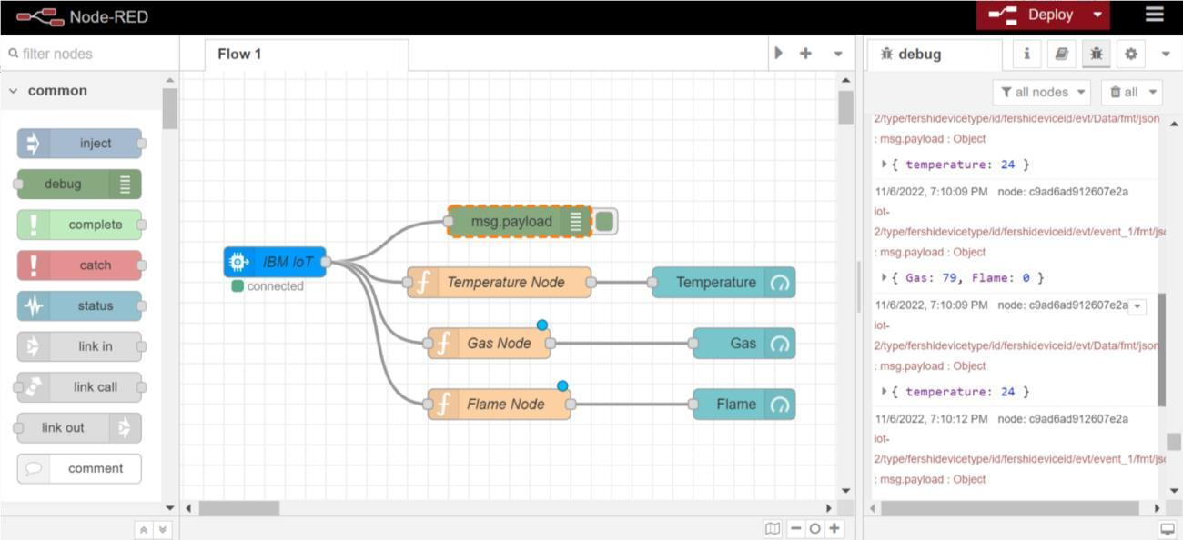

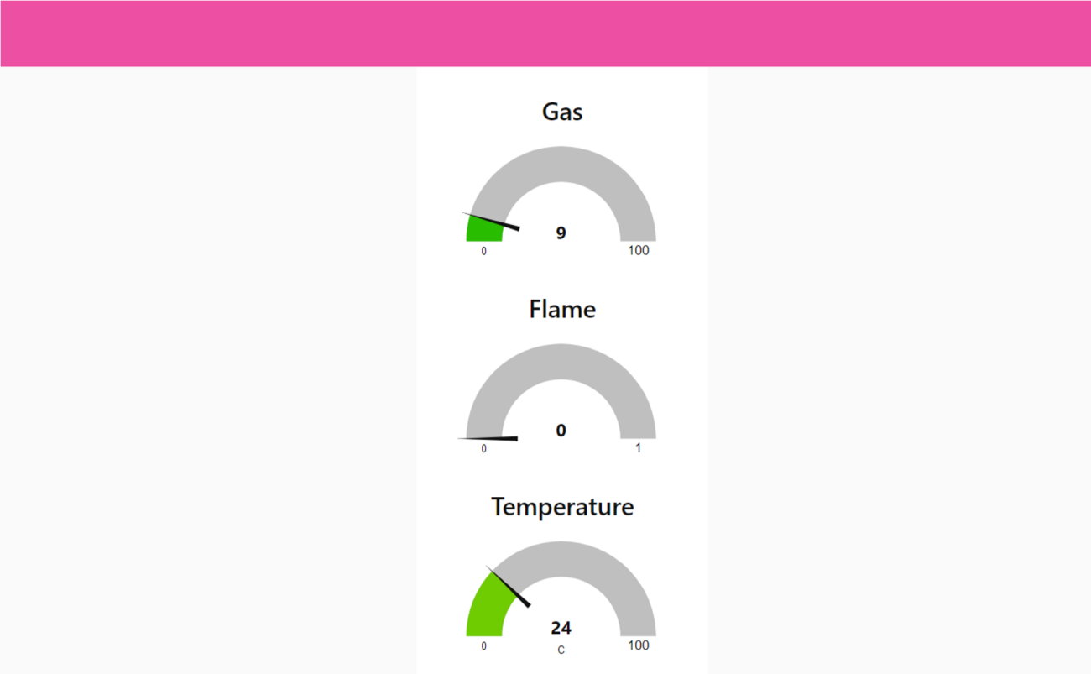

**Displaying gas sensor values:**

SUBMITTED BY: Balaji P (Team Leader), Akilan A, Dinesh S, Arun R

